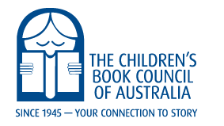

Book of the Year Judges for 2022 and 2023

Early Childhood
Katherine Burbeck NT
Bronwyn Joseph VIC
Gabrielle Anderson QLD
Younger Readers
Colleen Caddey ACT
Danielle Miller QLD
Claire Kierath - WA
Older Readers
Carol Fuller TAS
Kathryn Eyre NSW
Michael Earp VIC
Picture Book
Sarah Mayor Cox VIC
Margot Lindgren NSW
Sarah Forrest SA
Eve Pownall
Sheryl Cootes NSW
Alex Wharton NSW
Margaret Bromley ACT

